SHRI SANT GAJANAN MAHARAJ COLLEGE OF ENGINEERING



(Shegaon)

Shegaon, Buldhana-444203



A MINI PROJECT

REPORT ON



SUBMITTED IN PARTIAL FULFILLMENT OF

BACHELOR OF ENGINEERING

IN

COMPUTER SCIENCE and ENGINEERING

(2021-2022)

**SUBMITTED BY:**

Surabhi Ghanshyamji Lahoti(27)

Shreya Umesh Ingale(24)

Sanika Sudhir Sapkale(20)

Under the guidance of Prof. Pankaj K. Bharne

# **Certificate**

The project report entitled “CORONA TRACKER” is a bonafide work carried out in Third semester in a partial fulfilment of the requirements for Bachelor of Engineering in Computer Science and Engineering from Shri Sant Gajanan Maharaj College of Engineering, Shegaon during the academic year 2020-2021.

**SUBMITTED BY:**

Surabhi Ghanshyamji Lahoti(27)

Shreya Umesh Ingale(24)



Department of



C



omputer S



cience and Engineering



S



hri



sant



Gajanan



maharaj college of



engineering,shegao



n



Sanika Sudhir Sapkale(20)

Date:16/01/2022 Signature:

Prof. Pankaj K. Bharne



Acknowledgement



We would like to express our profound gratitude towards many individuals, as without their support would not be possible. We would like to extend our sincere thanks to our class counsellor Prof. Pankaj K. Bharne who gave us this chance in enhancing our capabilities.

I, Surabhi Lahoti appreciate and thank our teammates Sanika Sapkale and Shreya Ingale for their support and teamwork, without them I would have never succeeded in completing the project.

We would like to thank our Principal Dr. S .B . Somani, who provided us with the necessary facilities and advice. We are also thankful to Dr. S. B. Patil, Head of Computer Science and Engineering Department for his valuable suggestion and report. We are really thankful to Prof. Pankaj K. Bharne for his valuable guidance, suggestions and support for this project.

Also I would like to all teaching and non-teaching staff of the department who directly or indirectly supported and encouraged us through this project.

SUBMITTED BY:

Shreya Umesh Ingale

Sanika Sudhir Sapkale

Surabhi Ghanshyamji Lahoti



Content



Sr.No

.

Title

Page No



Chapter 1 Introduction

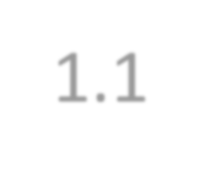

1.1



Aim

1

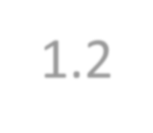

1.2



Objectives

1



Chapter 2 System Requirements



2.1

Hardware Requirements

2



2.2

Software Requirements

2



2.3

Literature

2

-

9



Chapter 3 Methodology



3.1

Web development components

10

-

1

2



used to develop an application



3.1.1

H

TML components us

ed to



make basic

structure

of web page



3.1.2

CSS Components used to design



an

application



JAVASCRIPT Components used

3.1.3



in an application



Chapter 4

Im

plication

13

-

16



Home page of website

4.1



Prevention Section

4.2



4.3

Symptoms Section



4.4

Precautions Section



4.5

Tracking Section



Hand

4.6

-

Wash and footer section



Chapter

5

Conclusion and References

17



5

.1

Conclusion



5

.2

References



COVID-19 outbreak was first reported in Wuhan, China and has as spread to more than 50 countries. WHO declared COVID-19 as a Public Health Emergency of International Concern (PHEIC) on 30 January 2020.Naturally, a rising infectious disease involves fast spreading, endangering the health of large numbers of people, and thus requires immediate actions to prevent the disease at the community level. Therefore, Corona Tracker was born as the online platform that provides latest and reliable news of various countries on COVID-19.



Abstract:



In today’s mobile and tech-savvy world, people can get information about COVID-19 at any moment. Almost 198 countries and union territories have face the spread of COVID-19.The users can get the current information about cases of COVID-19 in their countries as well as other countries in a fraction of minute using this website.

This project is a CORONA TRACKER is a website that gives the information about COVID-19 in various countries. This project gives information about active cases, total cases, critical cases, total deaths, recovered cases, total test done in particular country. This project also provide us the symptoms shown by the person who may have been infected by COVID-19. Along with that, the precautionary measures to be taken to prevent the spread of COVID-19.



# Chapter 1

**1. INTRODUCTION**

This **COVID-19 Tracking Project** provides the cumulative number of confirmed COVID-19 cases and deaths, as well as the rate of daily Covid-19 cases and death country. This tracker will be updated regularly, and shows information related **active case, critical cases, total cases, total deaths, recovered cases** and **total test** done in different countries.

Covid-19 is continuing to spread around the world, with more than 300 million confirmed cases and more than 5 million deaths reported across almost 200 countries. Naturally, a rising infectious disease involves fast spreading, endangering the health of large numbers of people, and thus requires immediate actions to prevent the disease at the community level. Therefore, COVID-19 Tracker is made as online platform that provides latest and reliable news development.

Here we also display the other information such as regarding **symptoms**, **precautions**, **tracking,** and **steps to wash hands**. This definitely results in effective ways in prevention from COVID-19 for people.

## **1.1 Aims and objectives**

COVID-19 Tracker project is a web Application used to track the ongoing details regarding the pandemic like cases and deaths also it tells the symptoms and precautions to be taken for safety. It also displays step for Washing Hands properly.

## 1.1.1 Aim

To be Alert regarding COVID-19 situations in different countries in the world with this COVID-19 tracking web Application.

### 1.1.2 Objectives

To track COVID-19 situation across the world.



To spread awareness regarding pandemic.

To help people to get known about current situations of Covid-19 in different countries in the World. To give information about the Symptoms visible.

To tell people which precautions to take for safety.

# Chapter 2

**2. System Requirements**

Following are the hardware and software requirements we use to develop this web application.

## 2.1 Hardware Requirements

The hardware requirement section covers the all the components required for providing us the platform for development of the project. The requirements are as follows:

* Processor**:** intel 3i or 5i
* Memory**:** 3GB RAM, 8GB RAM recommended  Screen resolution**:** 1280 x 800 minimum.

## 2.2 Software Requirements

Computer software is typically classified into two major types of programs: **system software and application software.** System software are programs that manage the resources of the computer system and simplify application programming. Following are the software’s used to develop web application project:

* Microsoft Windows 7/8/10 (32-bit or 64-bit) Operating System
* Visual Studio Code  Notepad++

## 2.3 Literature

2.3.1 History:

Coronavirus disease 2019 (COVID-19) is a novel disease caused by a newly identified virus, Severe Acute Respiratory Syndrome Coronavirus 2 (SARS-CoV-2). The novel disease which begun in Wuhan, China in Dec 2019 was declared pandemic by World Health Organization on 11 March 2020.

The novel human coronavirus disease COVID-19 has become the fifth documented pandemic since the 1918 flu pandemic. COVID-19 was first reported in Wuhan, China, and subsequently spread worldwide. The coronavirus was officially named severe acute respiratory syndrome coronavirus 2 (SARS-CoV-2) by the International Committee on Taxonomy of Viruses based on phylogenetic analysis. SARS-CoV-2 is believed to be a spill over of an coronavirus and later adapted the ability of human-to-human transmission. Because the virus is highly contagious, it rapidly spreads and continuously evolves in the human population. In this review article, we discuss the basic properties, potential origin, and evolution of the novel human coronavirus. These factors may be critical for studies of pathogenicity, antiviral designs, and vaccine development against the virus.

Currently, people all over the world have been affected by coronavirus disease 2019 (COVID-19), which is the fifth pandemic after the 1918 flu pandemic. As of now, we can trace the first report and subsequent outbreak from a cluster of novel human pneumonia cases in Wuhan City, China, since late December 2019. The earliest date of symptom onset was 1 December 2019. The symptomatology of these patients, including fever, malaise, dry cough, and dyspnoea, was diagnosed as viral pneumonia. Initially, the disease was called Wuhan pneumonia by the press because of the area and pneumonia symptoms. Whole-genome sequencing results showed that the causative agent is a novel coronavirus. Therefore, this virus is the seventh member of the coronavirus family to infect humans.

2.3.2Advantages

* Online education has grown over the last few years and experienced mainstream acceptance.
* Increases the human immunity and mind strength.
* Online Conversations and rapid growing technologies gave rise to a next generation world.
* Best time to spend time with family.

2.3.3Disadvantages**:**

* Loss of lives and happiness in the whole world.
* Tremendous loss of job of many people which results in financial problems.

Online classes affect the eyes of the students due to long hours in front of the blue screen.



All the activities involving a large public gathering like social, educational, political, economic and many other sectors got affected School, colleges, workplaces had to be closed down temporarily to avoid further spreading of the disease.

* This is the situation that made society very panic as well as very sensitive towards mankind.

# CHAPTER 3

**3. Methodology**

The Covid -19 Tracker is the web application and it is developed from HTML , CSS ,and JAVASCIPT using the Source code editor called Visual Studio Code. Visual Studio Code is a source-code editor made by Microsoft for Windows, Linux and macOS. Features include support for debugging, syntax highlighting, intelligent code completion, snippets, code refactoring, and embedded git.Visual Studio Code includes basic support for most common programming languages This basic support includes [syntax highlighting](https://en.wikipedia.org/wiki/Syntax_highlighting)[, bracket matching](https://en.wikipedia.org/wiki/Bracket_matching)[, code folding,](https://en.wikipedia.org/wiki/Code_folding) and configurable snippets. Visual Studio Code also ships with [IntelliSense f](https://en.wikipedia.org/wiki/Intelligent_code_completion)or JavaScript, TypeScript, [JSON](https://en.wikipedia.org/wiki/JSON)[, CSS,](https://en.wikipedia.org/wiki/CSS) and [HTML,](https://en.wikipedia.org/wiki/HTML) as well as debugging support for Node.js It contains four files, one is HTML File to create the basic structure of web page ,second is CSS file for describing the presentation of web page ,third file is of JAVASCRIPT for making web page interactive fourth file is of workspace file to save our work on laptop or computer . This three files are very important to develop web application. The HTML code and CSS code of our application’s first activity is shown below.

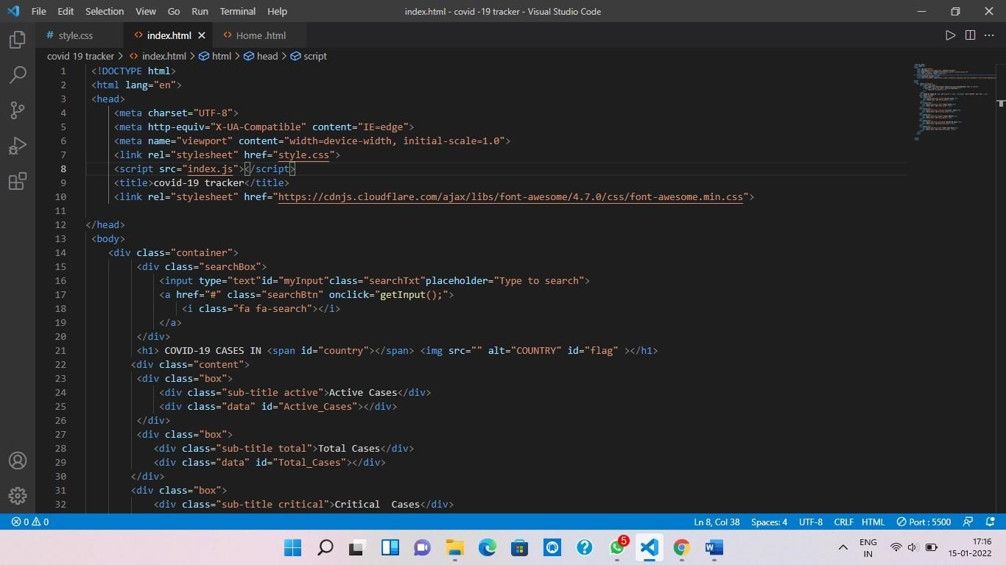

*Fig 3.1 : HTML code for basic structure of web page*

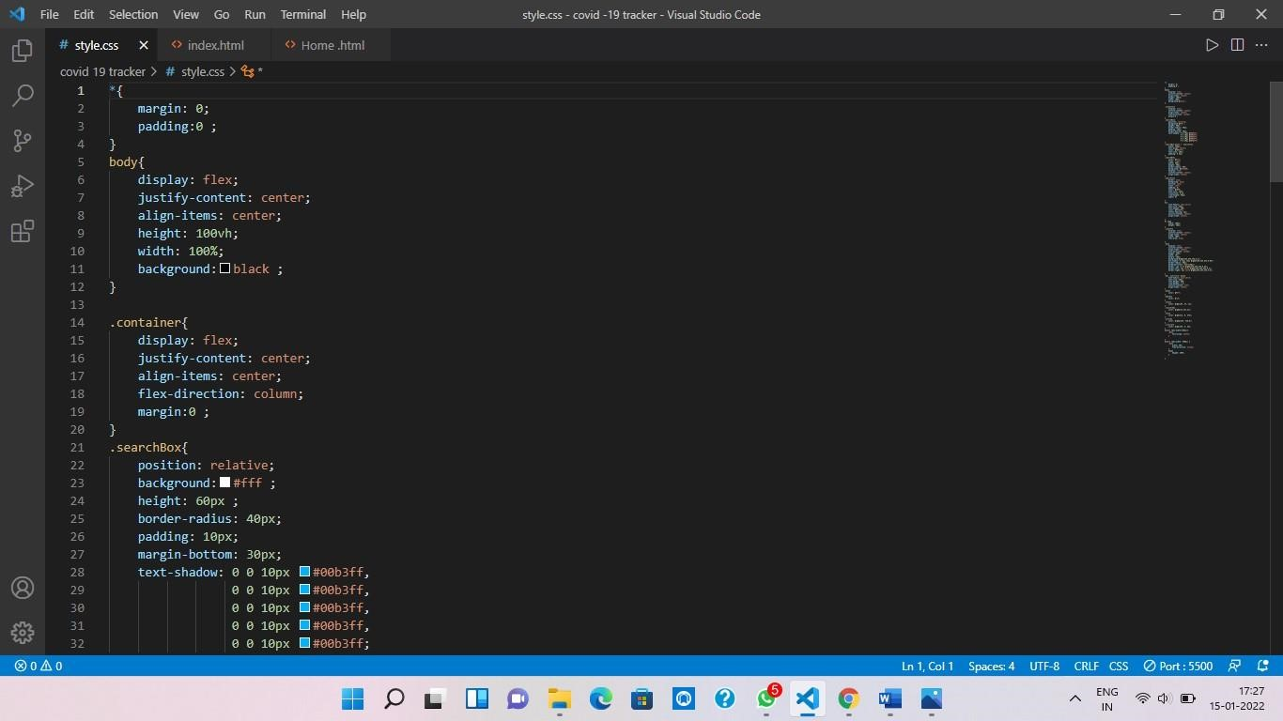

*Fig 3.2 :CSS code for designing the web pages*

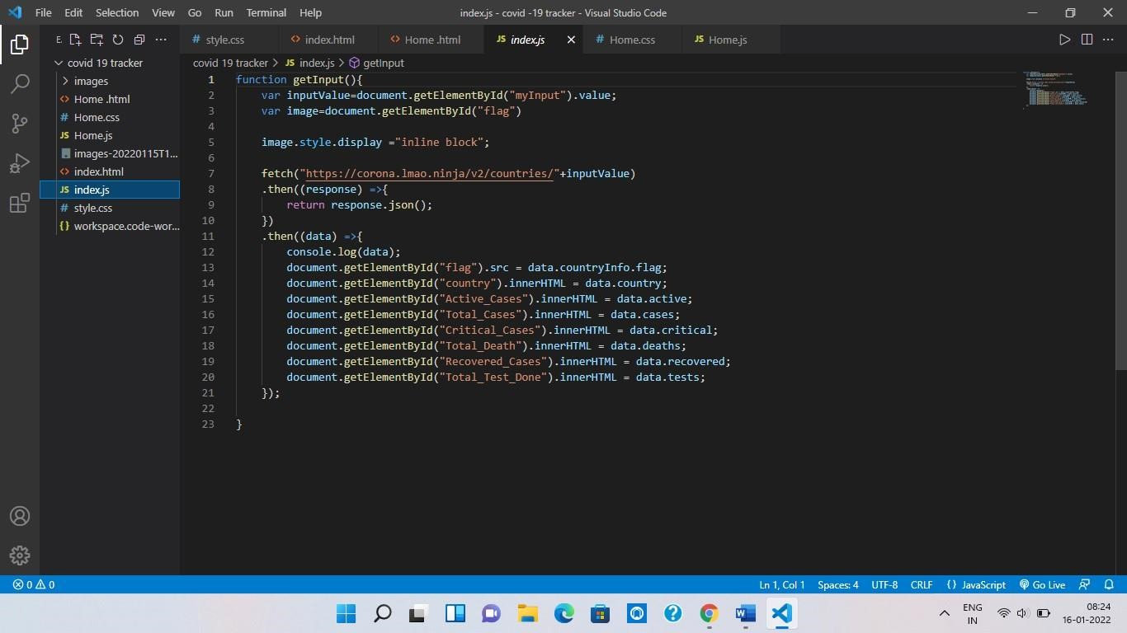

*Fig 3.3 : JAVASCRIPT code for making web page interactive.*

**3.1 Web Development Components Used to Develop an Application.**

3.1.1. HTML components used to make basic structure of web page:

* **Header**:

Usually a big strip across the top with a big heading, logo, and perhaps a tagline. This usually stays the same from one webpage to another.

* **Navigation bar**:

Links to the site's main sections; usually represented by menu buttons, links, or tabs. Like the header, this content usually remains consistent from one webpage to another.

* **HTML Tags:**

Different HTML tags are used in this application link div tag, a tag to add link, script tag to link JAVASCRIPT file to html file, h1 tag and many more.

* **Main content:**

A big area in the centre that contains most of the unique content of a given webpage, we add prevention, symptoms, tracking in the main content. This is the one part of the website that definitely will vary from page to page.

 **Footer:**

A strip across the bottom of the page that generally contains fine print, copyright notices, or contact info. The footer is also sometimes used for [SEO p](https://developer.mozilla.org/en-US/docs/Glossary/SEO)urposes, by providing links for quick access to popular content.

3.1.2. CSS Components Used to Design an Application:

* **CSS properties:**

Different CSS properties used for presentation of documents like font size, font colour, display, transition etc. We select the class and tag in html to apply the CSS properties to it.

* **Media query:**

To make the web application responsive we use media queries in our application so that our application is responsive on any device like mobile, laptop desktop etc.

3.1.3. JAVASCRIPT Components Used in an Application:

* **JAVASCRIPT functions:**

We use different JAVASCRIPT functions in our code which increases the reusability of program. It’s make easy to handle large code and also decreases the length of code.

* **API (Application Programming Interface):**

We use API through fetch function in our application to get the current data related to covid -19 in different countries in the world.

## CHAPTER 4

1. **. Implication:** 
   1. **. Home page of website:**

Initially, maintaining a home page of website for user is to get an idea of an application as it is visual expression to draw attention of the user.

After clicking on the link home page will be open as following:

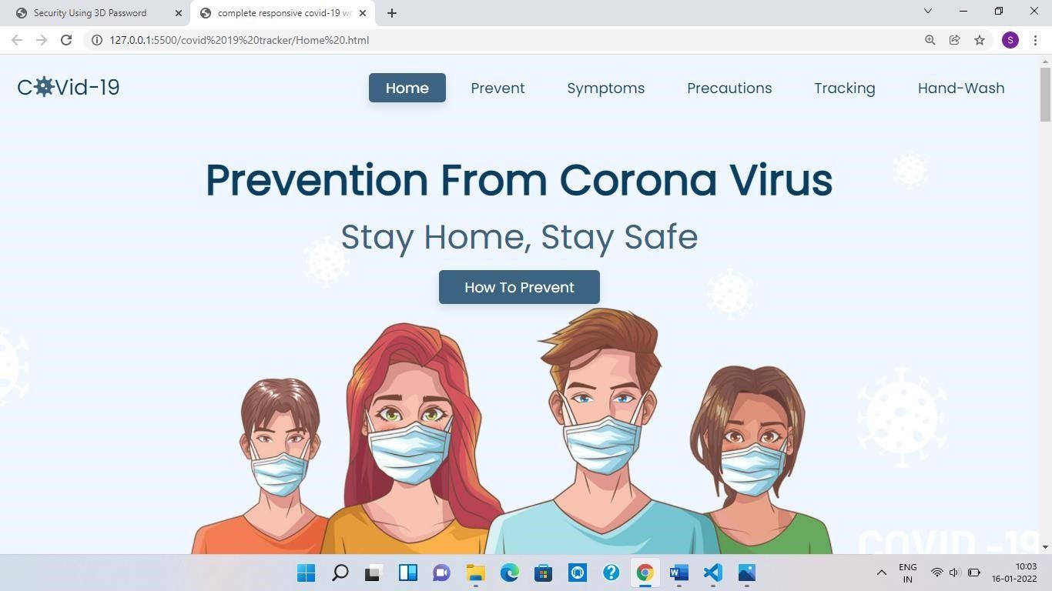

*Fig 4.1: Home page of website*

* 1. **Prevention section:**

On home page there is navbar on that different tabs of sections are available which are included in our website. Prevention is one of those section from all sections.

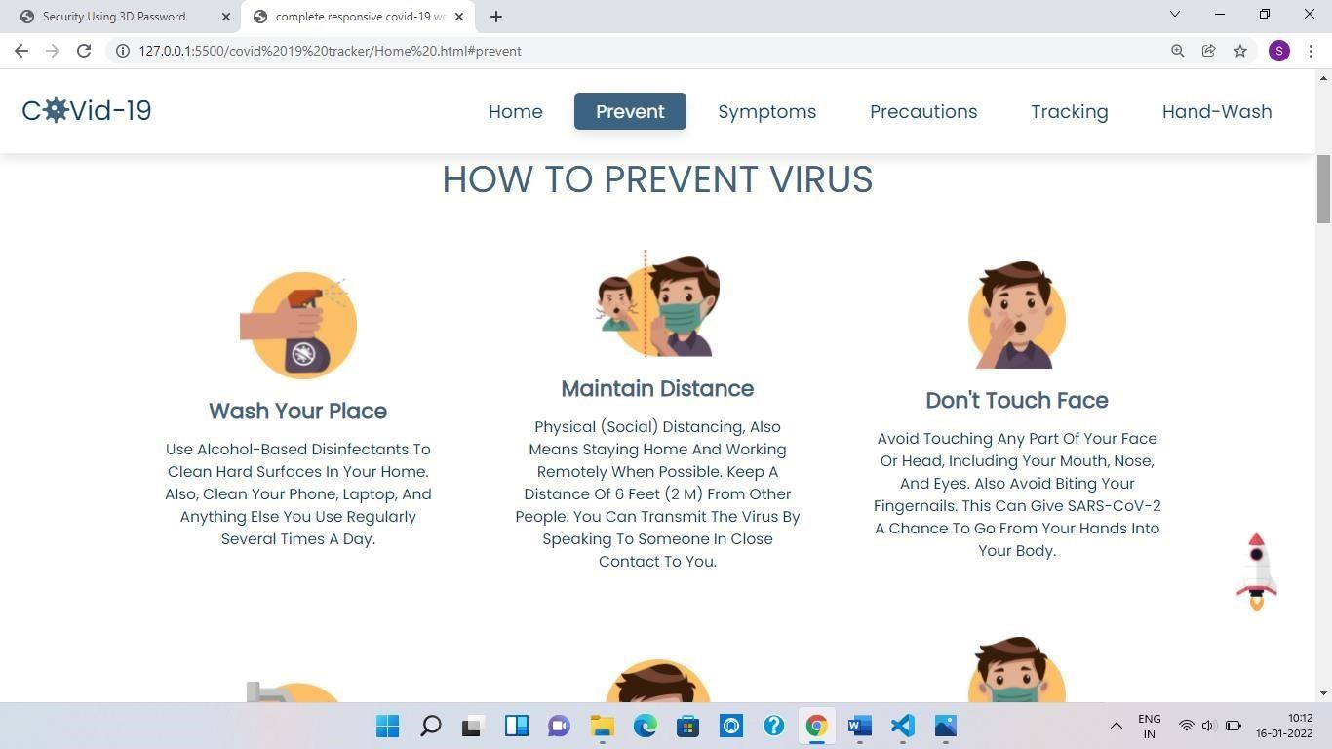

*Fig 4.2: Prevent section of site*

* 1. **Symptoms section:**

After prevention section there is symptoms section in which possible symptoms of covid 19 are included. Through this people get some basic information about covid 19 symptoms.

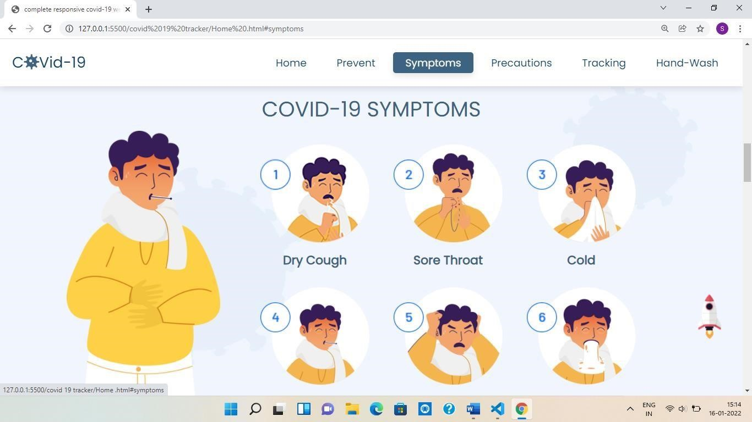

*Fig 4.3 : symptoms section of site*

* 1. **Precautions section:**

Precaution section is present after symptoms section in which do’s and don’ts are included which should be followed to everyone as a precautionary measure against covid 19.

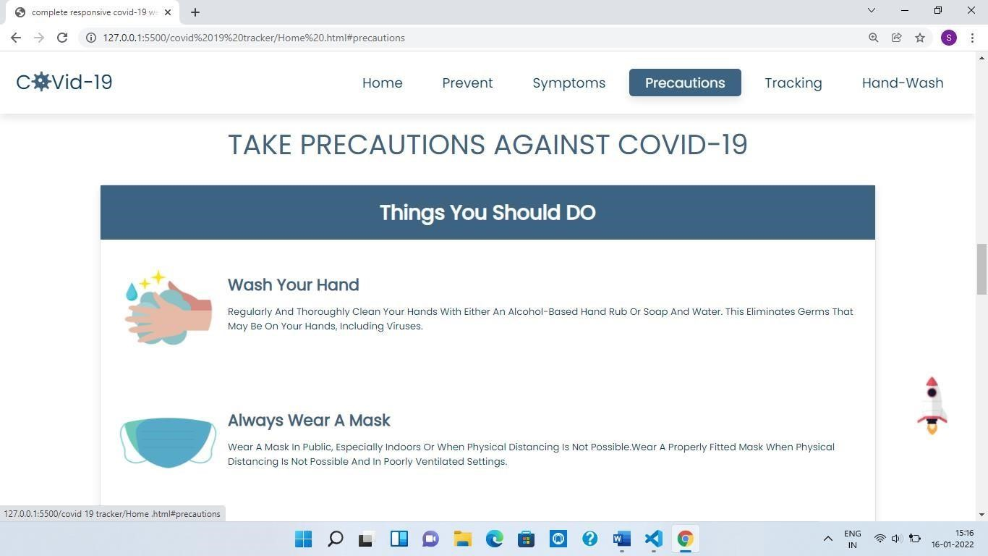

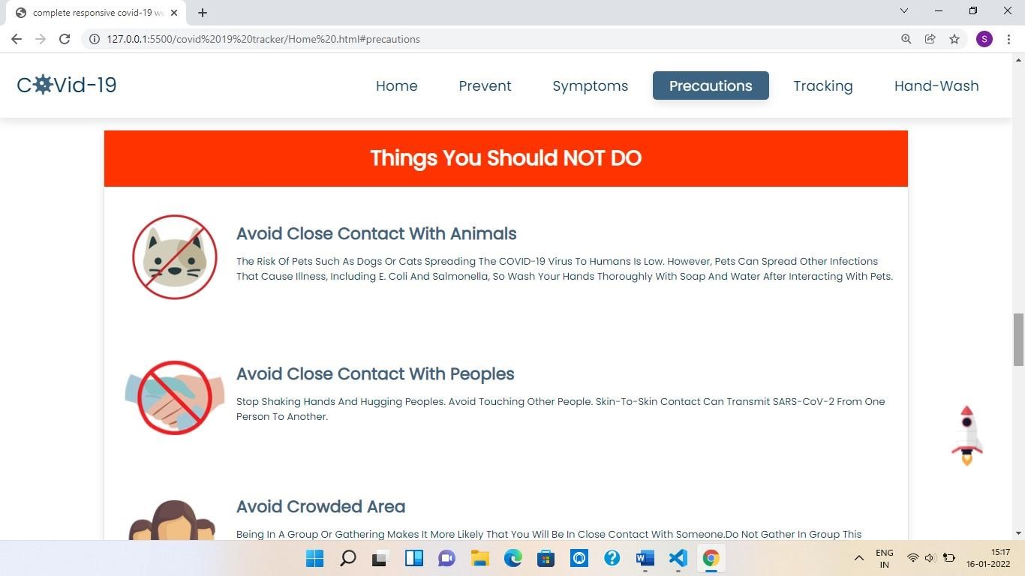

*Fig 4.4 : Precautions section of site*

* 1. **Tracking section**:

Tracking is the main section of site in this section after clicking in the option of ‘click here’ new window of covid 19 tracker will open and here you can enter name of any country and you get all the data related to covid 19.

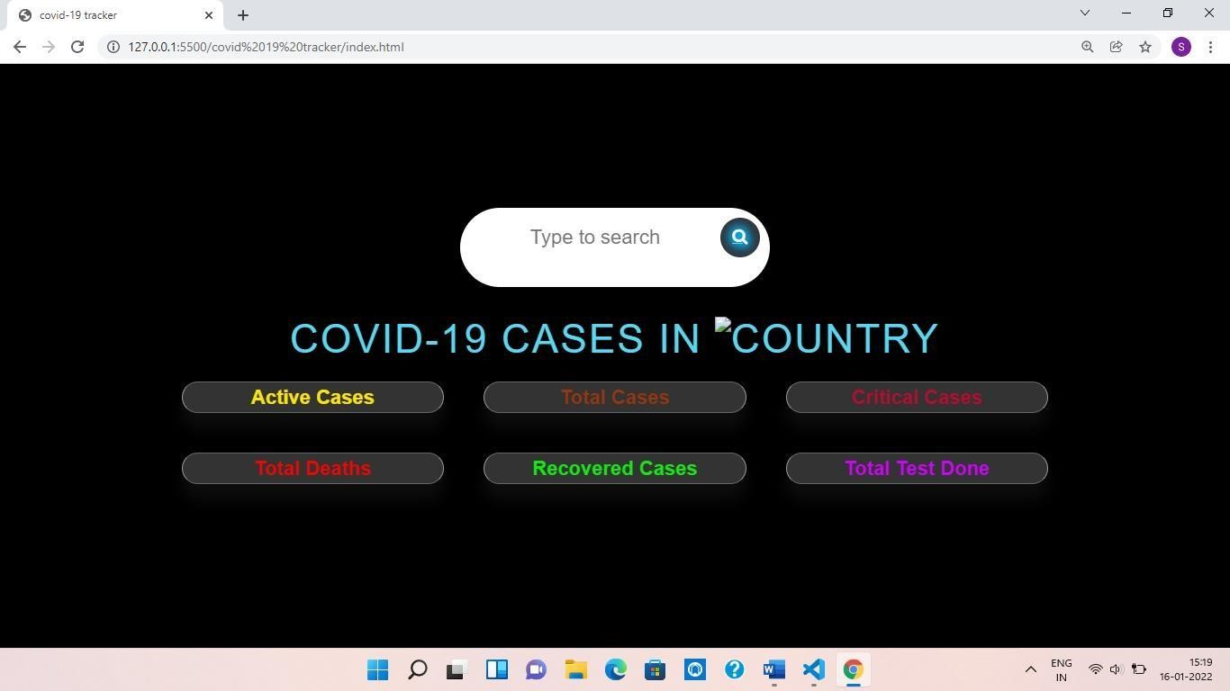

*By clicking*



*here the following new window*



*will open*

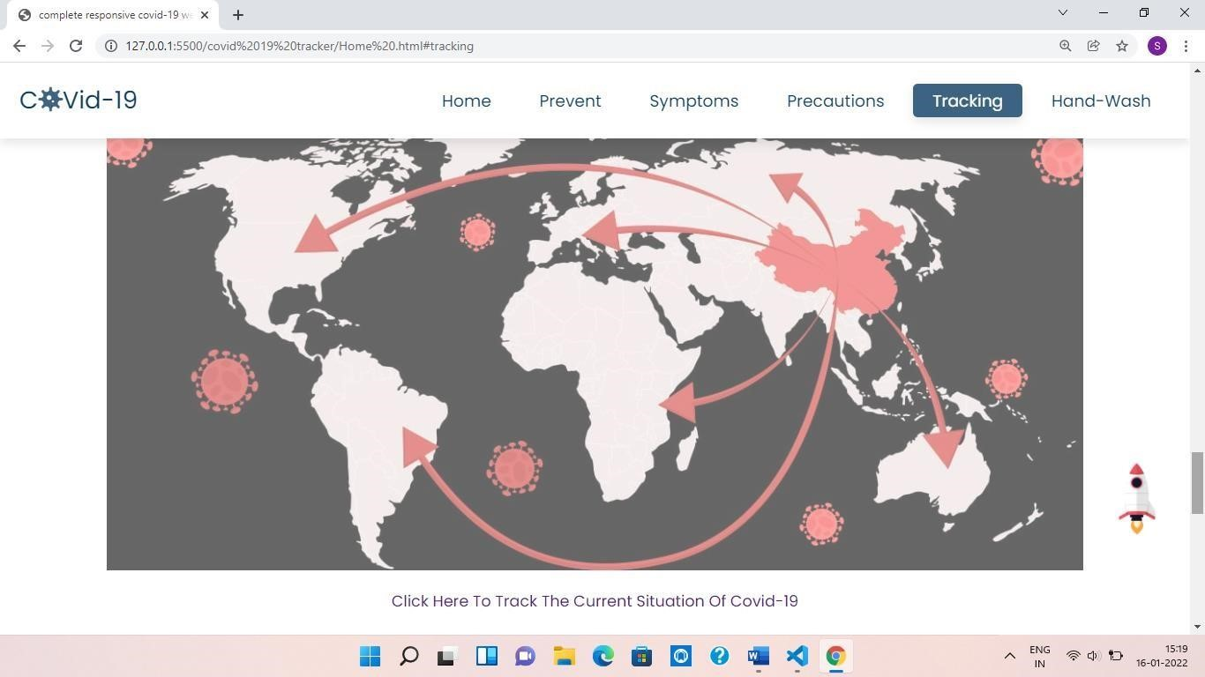

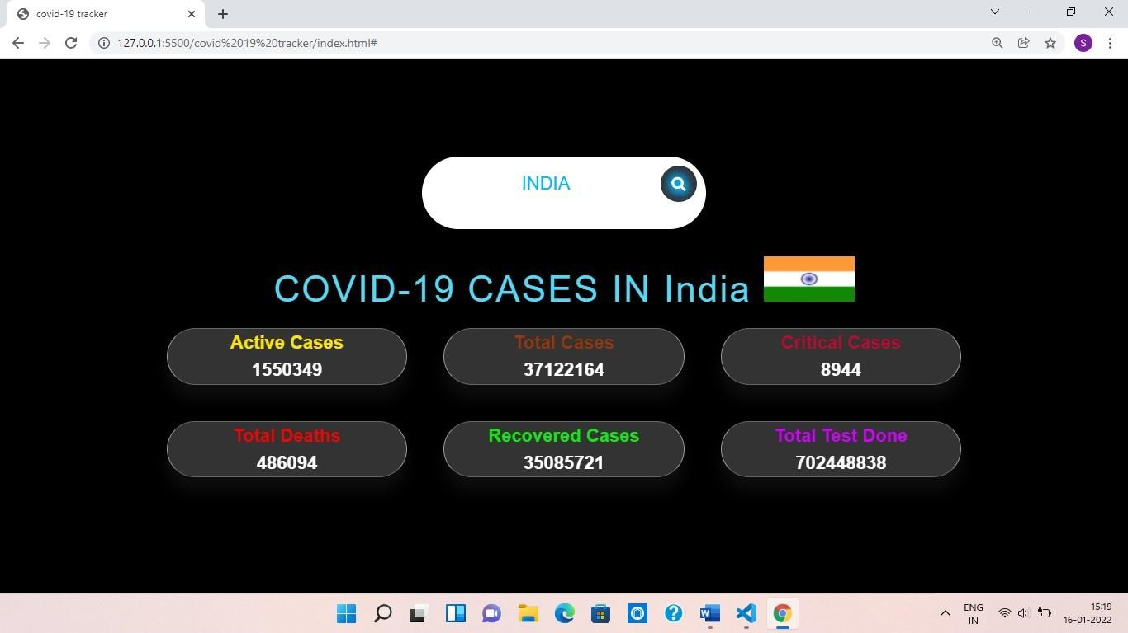

*Fig 4.5 : covid 19 tracker with data of India*

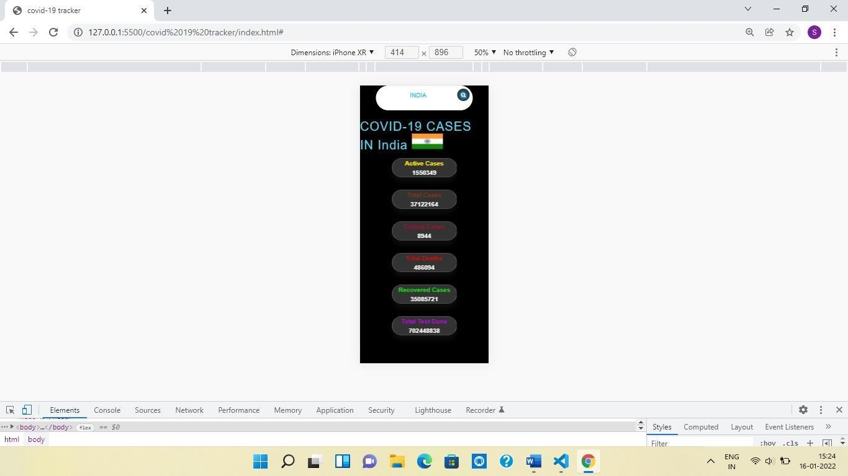

*Fig 4.6: Responsive covid 19 tracker*

* 1. **Hand -wash and footer section:**

Last section of site is hand-wash and footer section in this section proper steps of washing hands are included.

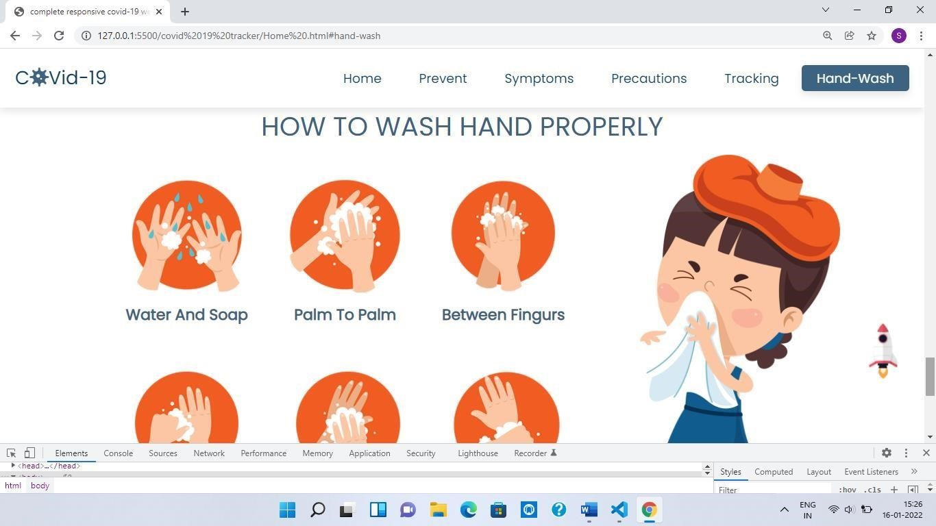

*Fig 4.7 : Hand -wash section of site*

# CHAPTER 5

**Conclusion and References:**

**5.1 Conclusion:**

In this project we had develop a covid -19 tracker web application which helps people to get current situation of covid 19 in different countries in the world. This application is useful for tracking the covid 19 situation across the world. This application is easier and more convenient for all peoples, also all the information will be available on their smartphone devices no matter where they are.

**5.2 References:**

* [https://www.ijert.org/covi](https://www.ijert.org/covid)[d-19-tracking-of-cases-in-javascript-and-php-withbiometric-scan-report](https://www.ijert.org/covid-19-tracking-of-cases-in-javascript-and-php-with-biometric-scan-report)

* <https://corona.lmao.ninja/v2/countries/>

* [https://developer.mozilla.org/e](https://developer.mozilla.org/en)[n-US/docs/Web/JavaScript](https://developer.mozilla.org/en-US/docs/Web/JavaScript)

* [https://www.geeksforgeeks.org/ho](https://www.geeksforgeeks.org/how)[w-to-create-a-covid-19-tracker-android-app/](https://www.geeksforgeeks.org/how-to-create-a-covid-19-tracker-android-app/)

